Waste Management

### PREPARED FOR

Information Technology Institute

### PREPARED BY

Islam Hany

Amal Assad

Aya Hassan

Christine George

# 1. Project overview

Waste Management for ITI building where workers are assigned specific floors to manage waste. Workers have Mobile or Web App where they can see wastebaskets state in real time.

# 2. Technologies Used

* Master Of Things AEP
* NodeJs
* ReactJs
* ReactNative (Cross Platform)
* Git and github

# 3. Technical Obstacles

* Remote work
* Multi user authentication system
* Handle Payment gateways
* Deployment

# 

# 4. Milestones and Reporting

|  |  |
| --- | --- |
| **Milestone** | **Tasks** |
| **1 - Analysis** | |
|  | Analysis and design stage, gather data and create system mockup |
| Architecture design |
| Design work plan (distribution of tasks to development teams) |
| **2 - Development** | |
|  | Create Application Forms (Database) |
| Create Pages for Admin to view all floors |
| Create Sensors for each floor |
| Create Consolidated Sensors to gather the floor's related sensors |
| Create Custom events to publish sensors' data to the mobile and web app |
| Create Web Application with NodeJs and ReactJs |
| Create Cross Platform Mobile Application Using ReactNative |
| Create Web Socket Server Using NodeJs |

**Github Repositories:**

[**React Native Mobile App**](https://github.com/IslamHany/WasteManagementApp.git)

[**ReactJs web App**](https://github.com/AyaHassan94/Waste-Managment/tree/Amaal_Server)

How it works?

**1- Admin:**

**Home Page**

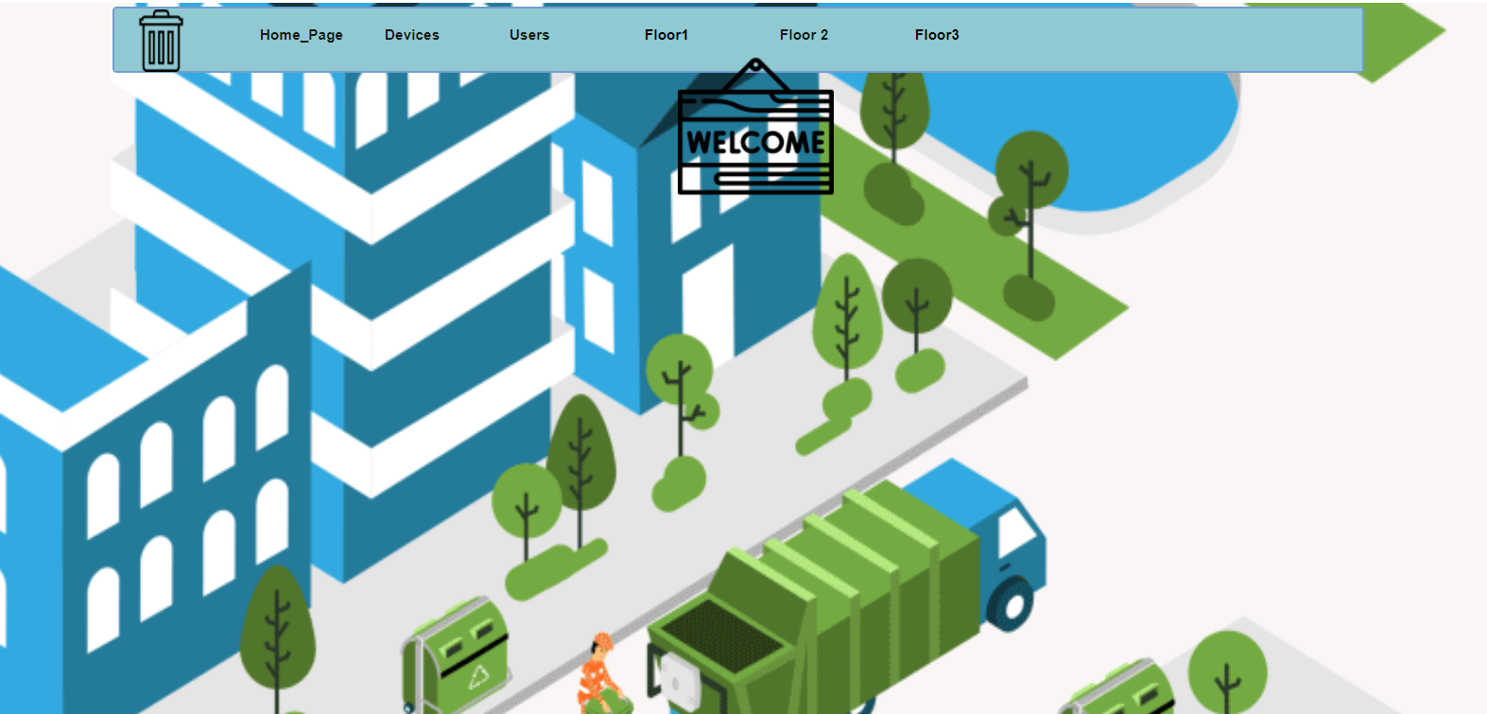

Welcome page for admin with nave bar which you can move to another page

**Devices Page**

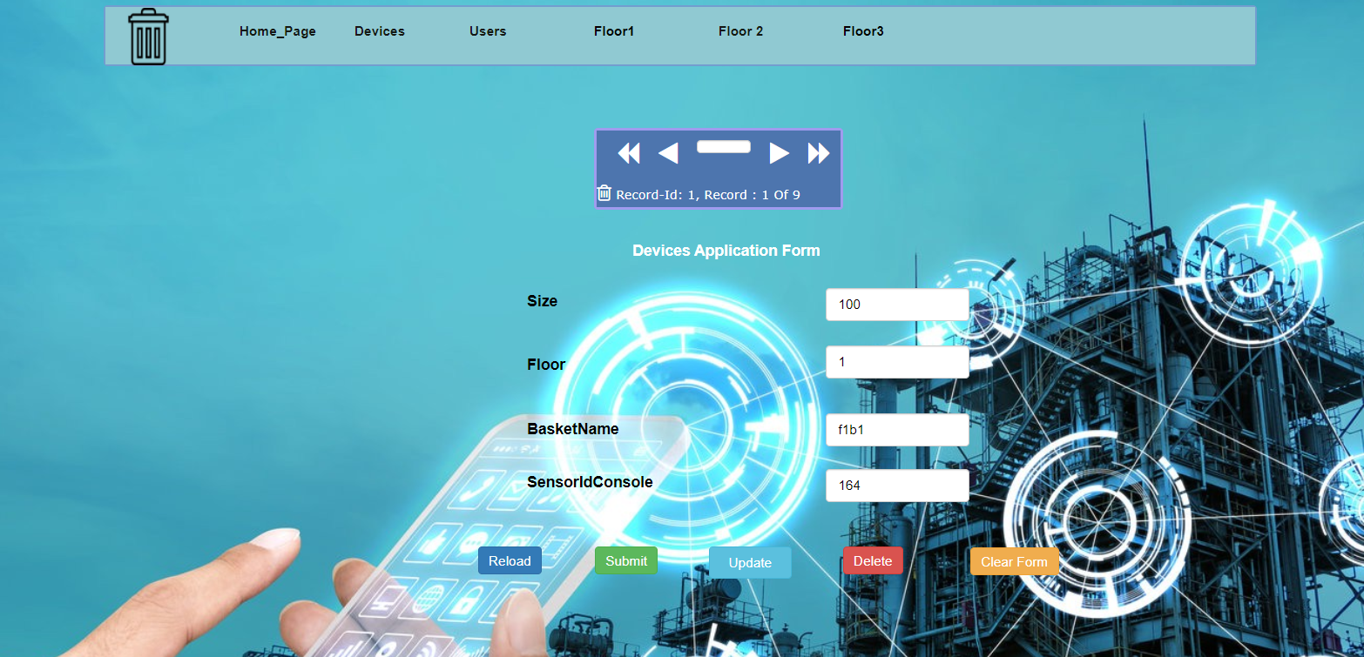

The admin has privilege to add new basket at any floor and record it through devices application form

**Users Page**

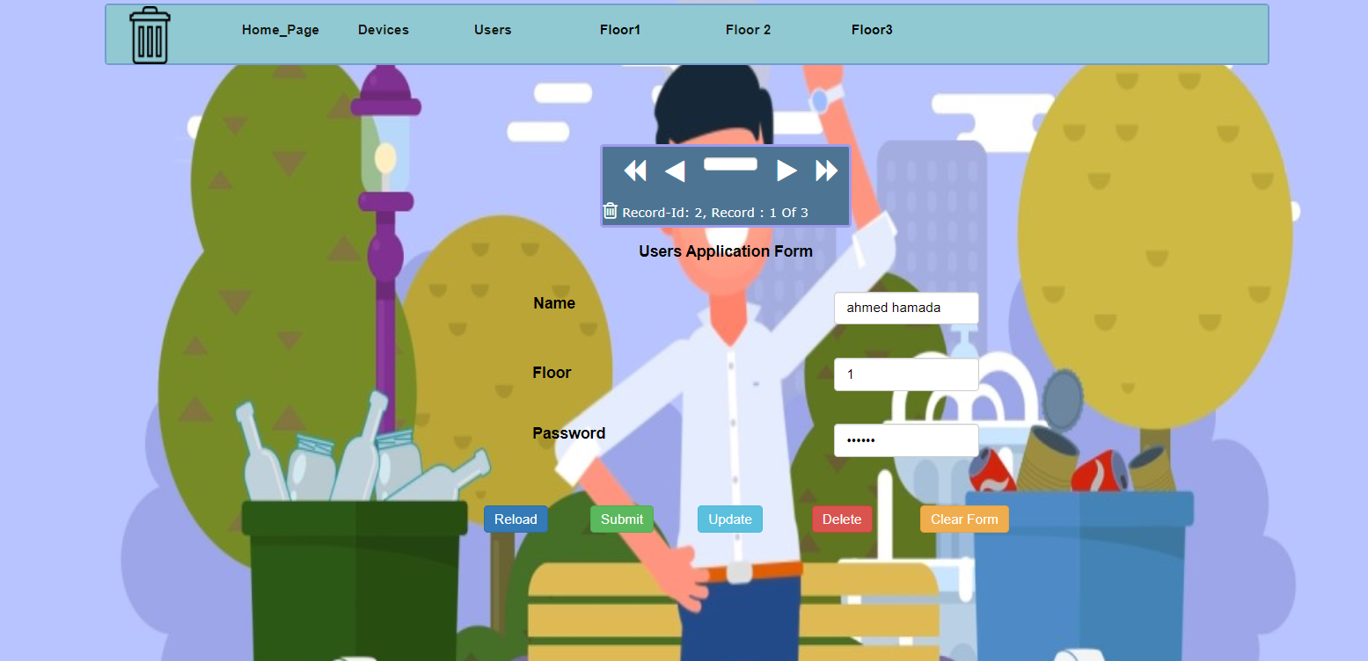

The admin can add any through users application form worker and assign a specific floor for him

**Floor Page**

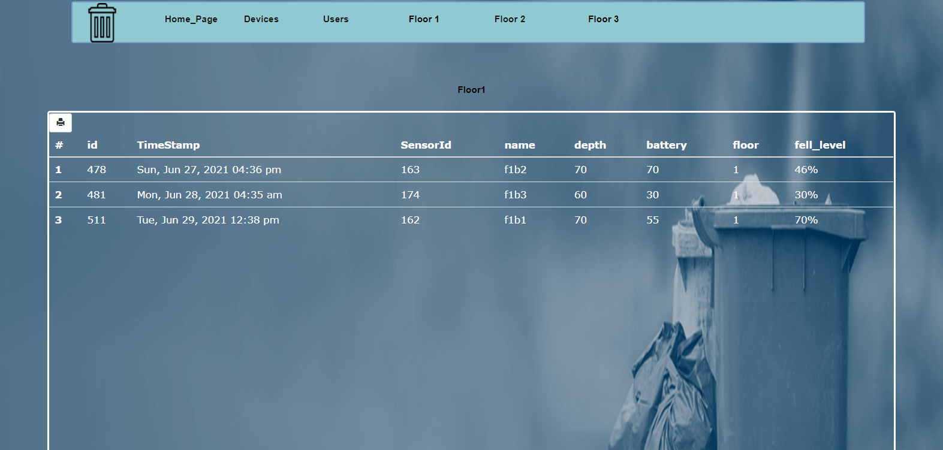

The admin has a privilege to access any floor’s data through floor’s table which has the recent data for any basket

**2-Mobile Application**

**Login**

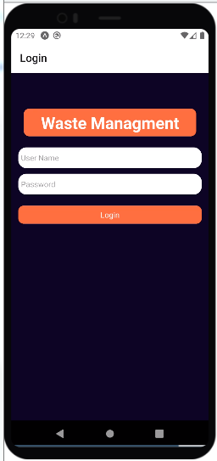

The worker can login with the credentials that the admin assigned to him

**View Baskets' state**

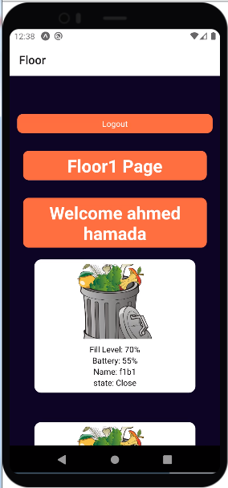

Now after login the worker can view all the baskets that is assigned to him in that floor and view the baskets' state at real time.

**3-ReactJs Web Application:**

**Home Page:**

Welcome page for managers for each floor in building with navbar where you can navigate between tabs.

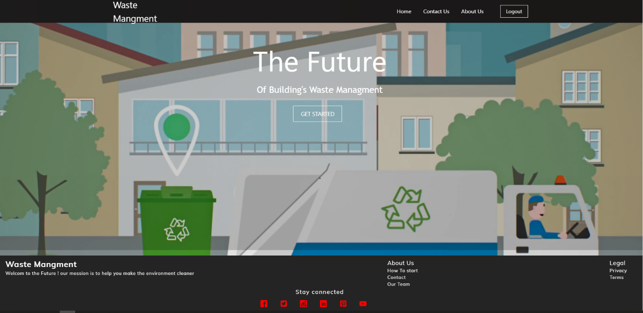

**Log In Page:**

Welcome page for collectors who admin give them credentials to log in to see details about wastes in their floors.

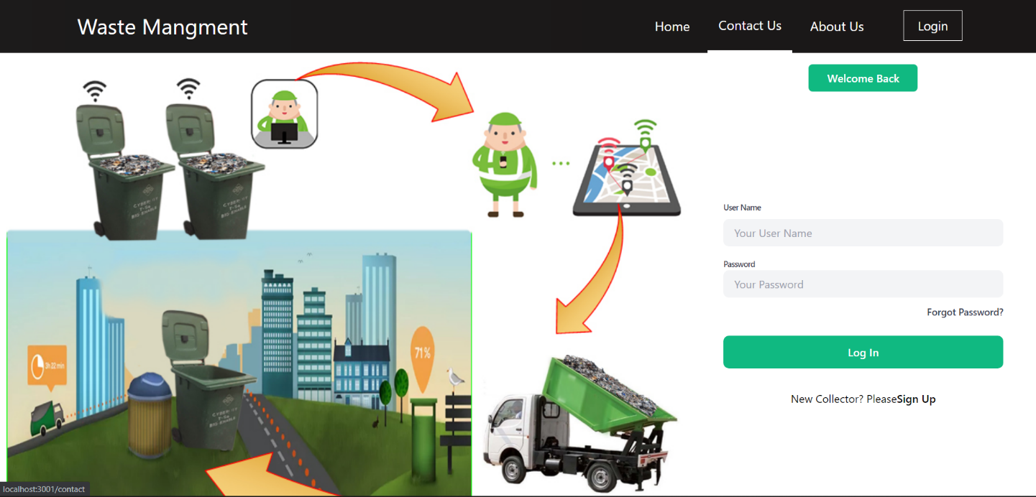

**Contact Us Page:**

Contact us page for collectors need more help about how to start to use application, questions sends to admins.

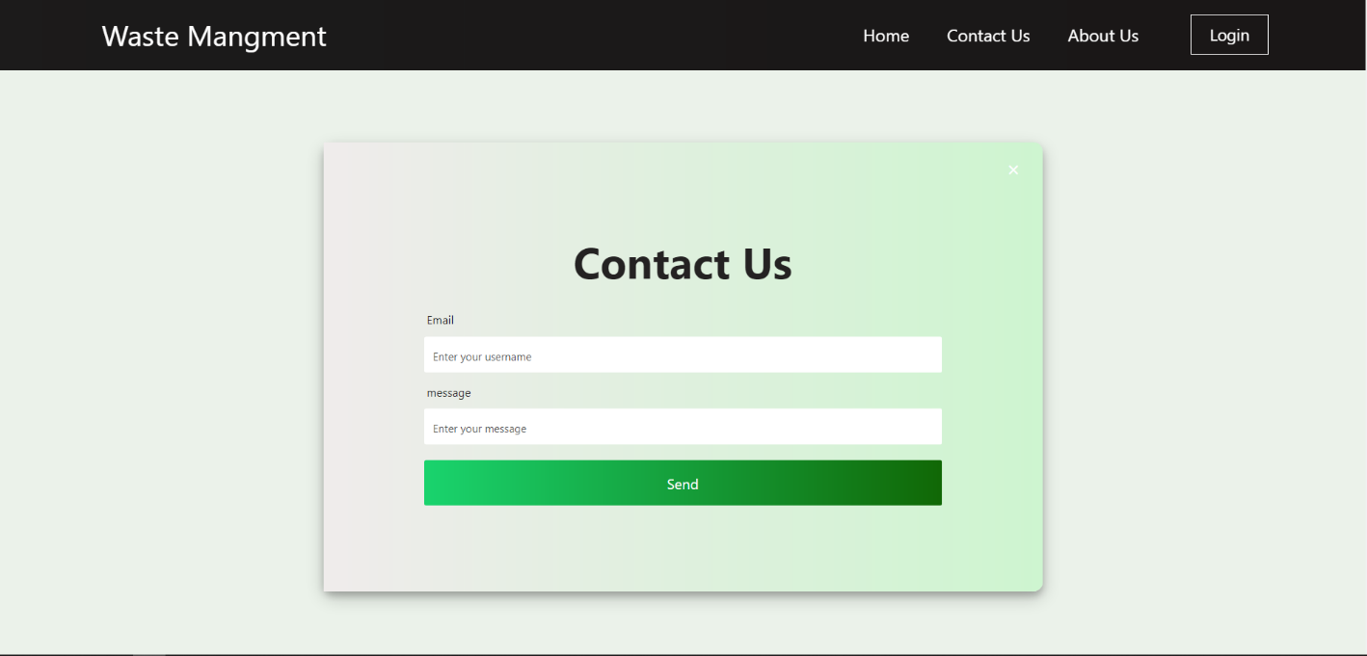

**About Us Page:**

About us page to meet our team who create this project and LinkendIn contacts for team members.

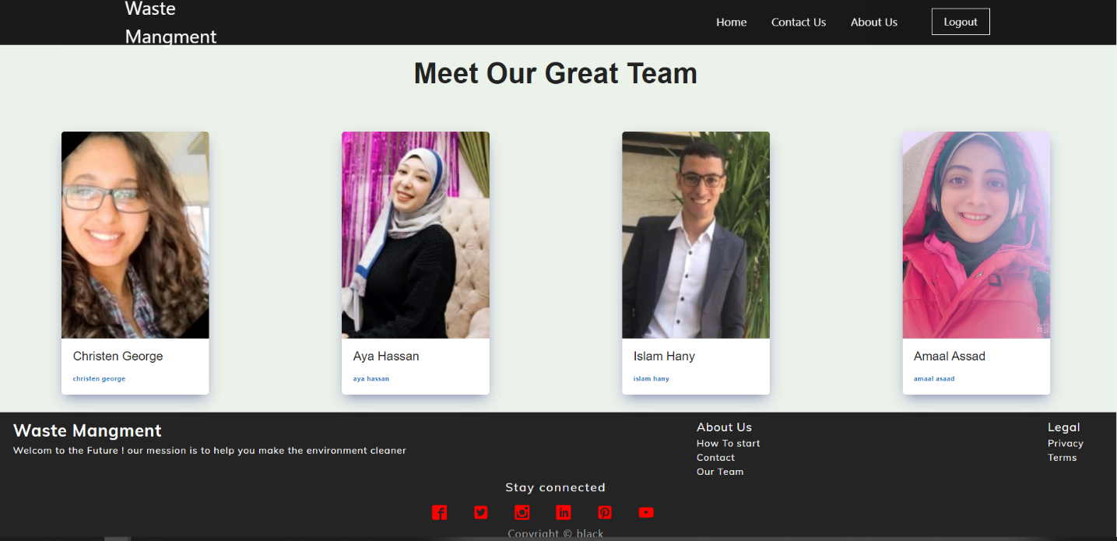

**User Home Dashboard Page:**

User Home Dashboard page where collector can see all updated information about all baskets in his relative floor in the runtime:

Each basket send 3 different information about it:

1) Fill Level Percentage => if it equal to 90% or higher (Basket will be Full and need to be empty by collectors.)

2) Battery Percentage of Sensor => if less than 10% (Basket Sensor need a new battery)

3) Basket State => is Basket Open Or Close.

